|  |  |
| --- | --- |
| torch.randon(2, 3) | 2x3 tensor whose values are random numbers from N(0, 1) |
| torch.linespace (-1, 1, 100) | 100 numbers equally spaced between -1 and 1 |
| torch.zeros (2, 3) | 2x3 tensor whose values are all 0 |
| torch.ones (2, 3) | 2x3 tensor whose values are all 1 |
| *x*= torch.ones (2, 3)  torch.normal (4* *x*, 1.7) | 2x3 tensor whose values are random numbers from N(4, 1.7) |

1. Print out the shape of *x*1*=*torch.linespace (-1 , 1, 100) and *x*2*=*torch.linespace (-1 , 1, 100) .view (100, 1). Explain the difference.

For Problem 2 and 3, let *x*1 = and *x*2= be two tensors.

1. Merge *x*1 and *x*2 by rows:
2. Merge *x*1 and *x*2 by columns $\left[\begin{matrix}1 & 2 & 3 \\ 4 & 5 & 6\end{matrix}\begin{matrix} 7 & 8 & 9 \\ 10 & 11 & 12\end{matrix}\right]$

For Problem 4 and 5. Let the training data be:

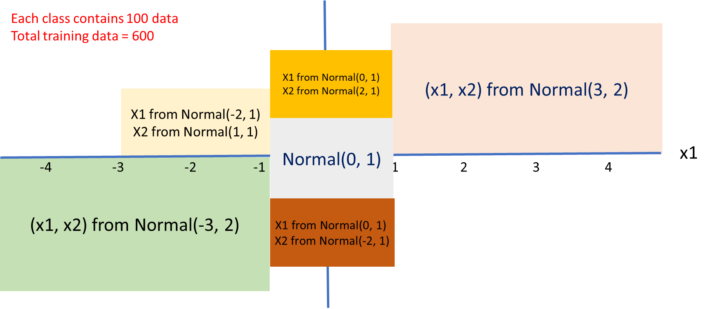

1. Define a dataset
2. Define a mini-batch data loader with batch size = 100.

For Problem 4 and 5. Download the 25,000 cat and dog image files from Kaggle: <https://www.kaggle.com/c/dogs-vs-cats/data>.

1. Read one image file. Resize its resolution to $80×80$. Read its values to a tensor *x* = [80, 80, 3]..
2. Read four image files. Resize to $80×80$. Read their values to a tensor *x* = [4, 80, 80, 3].
3. Read the 25,000 image files. Read their values to a tensor *x* = [25000, 80, 80, 3].
4. Define a mini-batch data loader with batch size = 5000.